**ADEBAYO ONAJOKO CONTOSO DATA ANALYSIS PROJECT**

**WHY IS DATA ANALYSIS AN IMPORTANT PART OF A BUSINESS?** In order for a company to get a sizable chunk of the market share in an ever-competitive market , the right questions needed to be asked and when the right answers are provided,such a company is bound to have a competitive edge over its competetions based on the the ground that the company’s decisions are informed by insights from detailed analyses of data generated from the running of the business over a period of time.

**GOAL OF THE CONTOSO DATA ANALYSIS PROJECT** This project is aimed at analysing the sales datasets from the fictitious microsoft company called Contoso and provide answers to some salient business questions being asked. The answers provided are meant to provide great insights for the company to make informed decisions.

**TOOL USED FOR ANALYSIS AND VIZUALIZATION:** Microsoft Power BI

**RESULTS OF THE PROJECT** The results are reports of analyses presented using visuals from Microsoft Power BI coupled with written recommendations to help the company maximize profits by increasing sales,cutting costs and also improve the overall customer experience and gurantee their continuous patronage.

**HOW DOES THE DISCOUNT, PROFIT AND SALES VARY OVER THE 3 YEARS COVERED IN THE DATASET?**

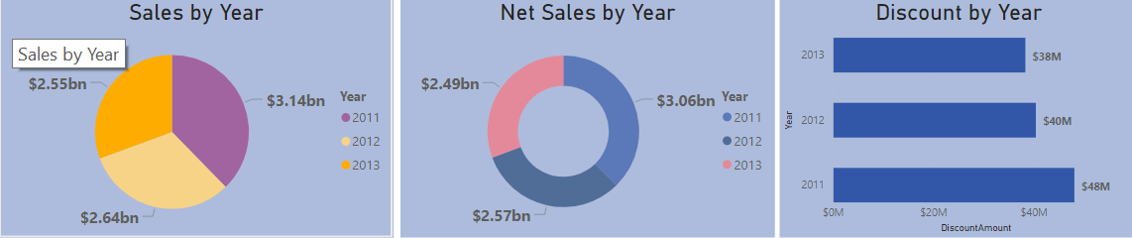

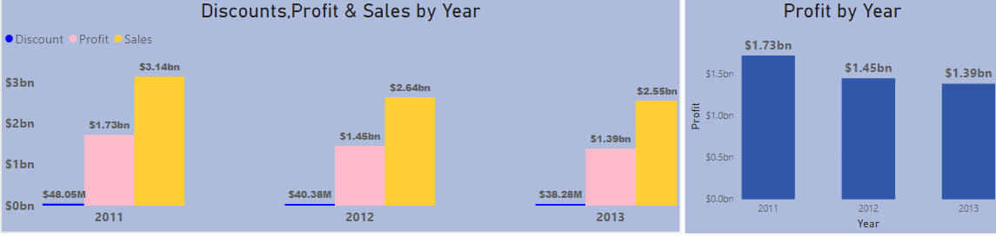

The Visuals above show the correlation between the total discounts given, the sales and the corresponding profits for the 3 years covered in the data set. The visual shows that the highest sales of $3.14B was recorded in 2011 and that was also the year with the highest discount of $48.05M and the lowest sales was recorded in year 2013 with value of $2.55B with a corresponding discount value of $38.28M. This shows 15.96 % drop in sales from 2011 to 2012 and a further drop in sales of 3.33% in 2013 i.e., an overall drop of 18.76% from 2011 to 2013. Since the analysis shows that the sales and profit went down with decrease in discounts - I will strongly advise the company to offer more promotional sales to give more discounts so as to increase the sales and corresponding profits going forward.

**WHICH CHANNELS ARE MOSTLY USED BY CUSTOMERS?**

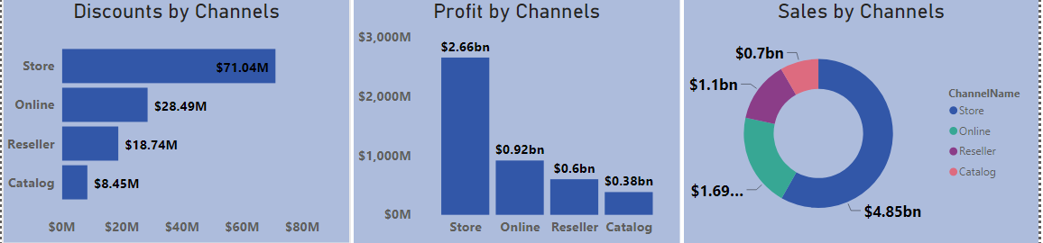

Based on the analysis carried out on the dataset, I discovered that customers mostly make use of the Store channel and the least used is the Catalog channel. In order to boost overall company sales, the company needs to create more customers’ awareness on the scarcely used channels. Also, since the result of the analysis shows that sales and profits for the different channels are directly proportional to the amount of discount offered by the channel – a likely effective measure to improve sales from the less used channels is to increase the discount being offered for such channel.

**WHICH ARE THE BEST PRODUCT CATEGORIES?**

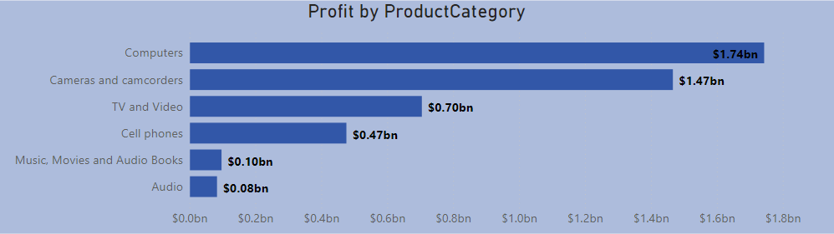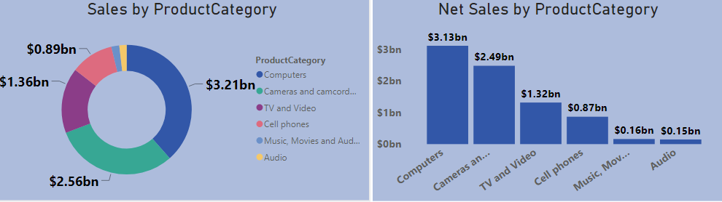

The above report is to show the sales and profits made from different Product Categories. The highest sales and profits came from the Computer Category followed by the Cameras and Camcorders Category and the least profitable category is the Audio Category. In order for the company to make profit from the different product categories, emphasizes must be placed on the most profitable categories and add a bit of products from the less profitable categories. Alternatively, the company could also bargain for cheaper prices for the less profitable categories in order to boost the sales for such product categories.

**WHAT ARE THE TOP 10 AND BOTTOM 10 SELLING PRODUCTS?**

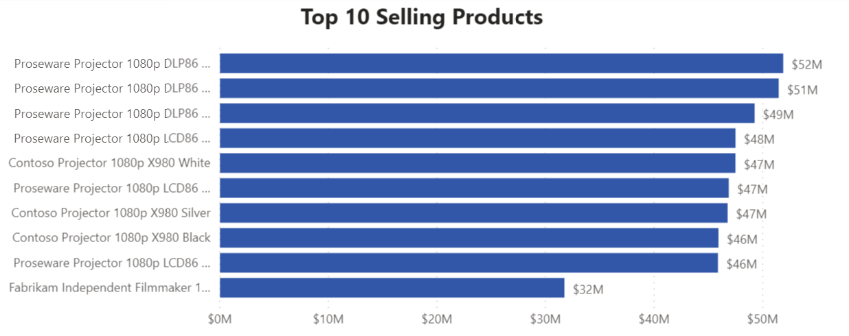

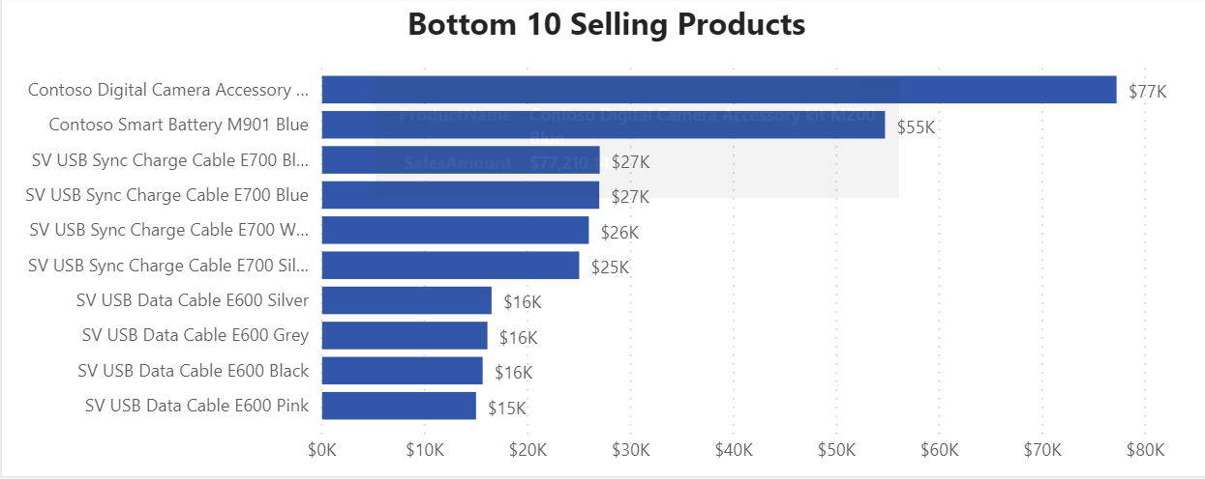

The above visuals of top 10 and bottom 10 selling products show that the lowest sales of the top 10 products sold about $32M while the bottom 10 products all sold below $80K. Due to the extreme gap between the 2 categories, it’s hugely profitable and makes more business sense to invest more on the top 10 products and stop the sales of the bottom 10 products.

**WHAT ARE THE RETURNED QUANTITY FIGURES ACROSS THE COMPANY?**

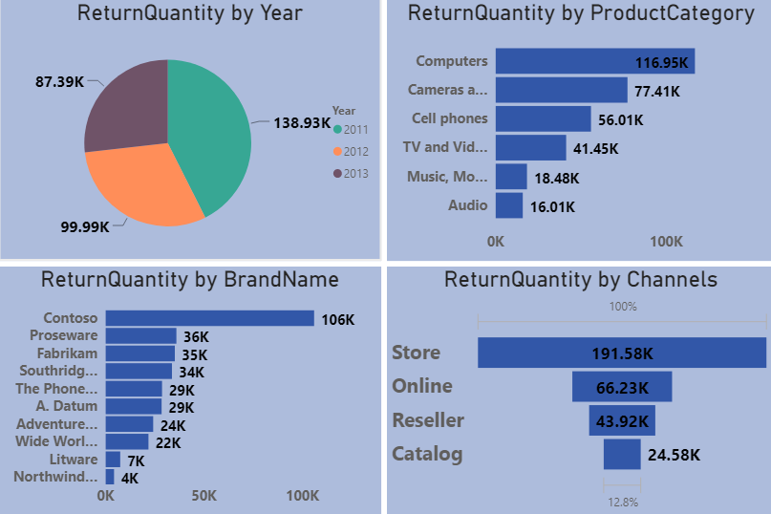

It can deduced from the analyses that the quantity of returned goods reduced significantly from 138.93K in 2011 to 87.39K in 2013. Also,the returned quantity maintained a similar trend over the 3 years based on Product Category and the Channel of Purchase but a few exchange of places were seen in the returned quantity based on brand names. An investigation should be carried out to find out reasons behind goods being returned and proactive measures taken to drastically reduce the quantity returned in the future of the business.A high value of returned goods is an indication of unsatisfied customers and more needs to be done to make the customers happy with the goods they get from the company and would have no reason to return them.

**WHICH STORES ARE THE BEST/WORST PERFORMING BASED ON SALES**

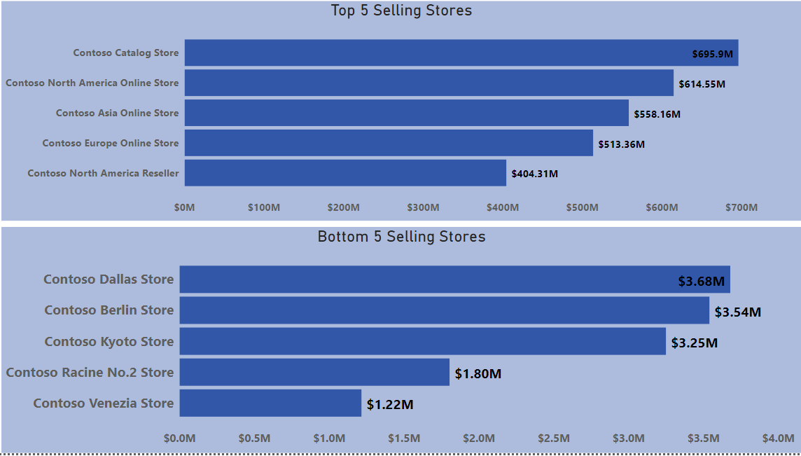

The report above shows the Sales Performance of the top and bottom 5 stores. The Top 5 stores all made over $400 million in the course of the 3 years under review while the 5 stores at the other end of the spectrum all made less than $4 million. Due to the huge gap between the sales performance of the 2 sets of stores, the management might need to look into the option of either taking drastic measures to transform the poor performing stores to profit making entities or consider closing them permanently.

**WHAT DOES THE SALES AND PROFITS DISTRIBUTION LOOK LIKE BASED ON THE GOODS’ MANUFACTURERS?**

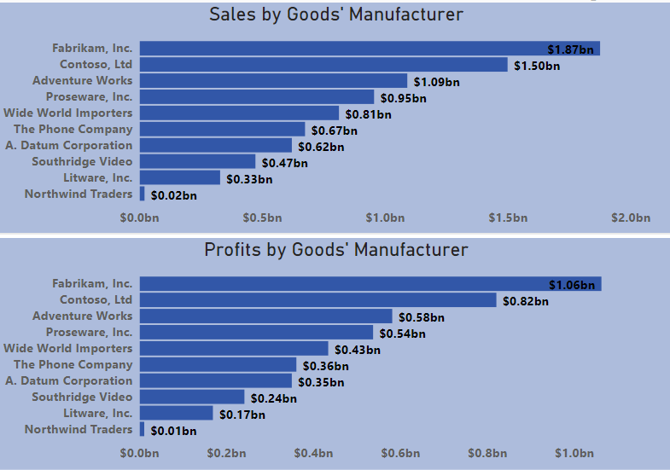

The above report shows the sales and profits made from goods categorized based on the manufacturers of such goods in the data set. It shows that the largest sales were made from products of Fabrikan, Inc. with total sales of $1.87B while the lowest sales were made from goods manufactured by Northwind Traders with total sales of $0.02B. It can also be seen that the goods from Fabrikan, Inc. are the most profitable with a total profit value of $1.06B just as the goods from Northwind Traders are the least profitable with a total profit of $0.01B. Furthermore, the customers’ preference for goods manufactured by the top manufacturers as shown in the above report is most likely due to world class quality of goods and great pricing and as such, I will suggest an increased patronage of such manufacturers in order to increase overall sales and profits.

**WHAT ARE THE QUARTERLY FIGURES FOR THE 12 QUARTERS IN THE YEARS COVERED IN THE DATA SET?**

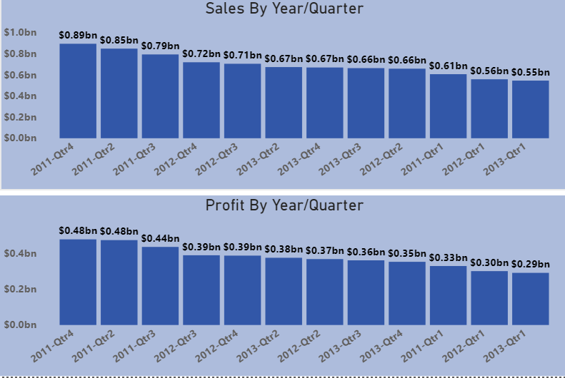

The above shows the manner in which the sales and the profits vary across the 12 quarters in the 3 years covered in the data set, a new column of " YearQuarter " which is a concatenation of the Year and the Quarter column was created using DAX and the sales and profit columns were then measured against the " YearQuarter " column. It should also be noted that Profit is a new measure created using DAX.

**SOME IMPORTANT MEASURES IN THE ANALYSIS**

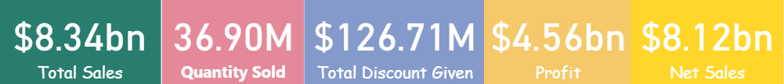

Above are the value of some important measures calculated from the three years data obtained in the course of running the business.